Investment Banking Recruiting Timeline 2027: When Everything Actually Happens
Meta description: Investment banking recruiting timeline for 2027: when Summer 2028 applications open at each bank, when HireVues and superdays run, and what to do this fall.

The investment banking recruiting timeline for 2027 is already running: if you're applying to Investment Banking Summer Analyst programs in 2027, you're competing for Summer 2028 seats, and the first applications opened in September 2026. Evercore opened its Summer 2028 application in the second week of September 2026 and closes it on November 15, about four months earlier than its last two cycles. [VERIFY: Evercore's job board dates (Extern says September 9, Superday AI says September 8) and Superday AI's four-month comparison] The bulge brackets are expected to post in December 2026 and January 2027, interviews and offers run from January to May 2027, and middle market banks keep posting through the fall of 2027.

In this article, I lay out the whole investment banking recruiting timeline month by month, from the sophomore programs closing this fall to the return offer at the end of Summer 2028.

When do investment banking summer analyst applications open for 2027?
The elite boutiques open first, between September and November 2026, and the bulge brackets follow in December 2026 and January 2027. [VERIFY: bulge-bracket opening months against the postings as they appear] Evercore is already open and closes November 15, Harris Williams's own page gives its window as October 2026 to January 2027, and Extern expects Barclays and Deutsche Bank in late November, JPMorgan and Citi in December, and Goldman Sachs, Morgan Stanley and Bank of America in January, based on when each one posted last cycle. Middle market banks like Baird and Piper Sandler post from late December into February, and some keep posting into the fall of 2027. Almost every one of these is rolling, so the day a posting goes up is the real deadline.

Is it too late to apply for a Summer 2028 investment banking internship?
No. As of October 11, 2026, no bulge bracket has posted, almost no middle market bank has posted, and Evercore's application stays open until November 15. [VERIFY: posting status at publish] What has mostly closed is the sophomore program layer: Goldman's Emerging Leaders Series closed in early October (its page now says "Applications are now closed") and Jefferies' Insight Day closed October 2, while Morgan Stanley Early Insights (October 30), the Moelis Leadership Development Program (October 22) and Citi Early Identification (October 23) are still open this month. A sophomore reading this in October is on time for every bulge bracket seat, every middle market seat and most of the boutiques.

The whole investment banking recruiting timeline on one page
This is the cycle for a sophomore graduating December 2028 to June 2029, from the first deadline this fall to the private equity interviews that come after the full-time job starts. A date from a firm's own page is stated as fact. A date from a tracker's projection says "expected." A date from a forum says "reported." Where two sources disagree, the row gives the range. Each period gets its own section below.

Period | What happens | Who
September to November 2026 | Sophomore and insight programs close: Goldman Emerging Leaders early October (closed), Houlihan Lokey Insight Day October 19, Moelis LDP October 22, Citi Early ID October 23, Morgan Stanley Early Insights October 30. Evercore's Summer 2028 application runs from September 8 or 9 (the trackers differ by a day) to November 15. Harris Williams opens in October. Perella Weinberg's TPH Houston group closes November 10 and Moelis Houston closes December 14 (both reported by Extern). [VERIFY: each date at publish] | Elite boutiques; sophomore programs at bulge brackets and boutiques
November 2026 to January 2027 | JPMorganChase Fellowship expected to open in November and close in mid-January. Barclays and Deutsche Bank expected late November; JPMorgan, Citi, Lazard and Jefferies expected December; Goldman Sachs, Morgan Stanley, Bank of America, UBS, Wells Fargo, PJT, Centerview and Guggenheim expected January (Extern's projections from last cycle). Moelis's other US offices expected late December. Harris Williams closes in January. [VERIFY: each posting as it appears] | Bulge brackets; the rest of the elite boutiques
January to May 2027 | HireVue invitations within hours to a week of applying. First rounds and superdays from January. The accelerated boutiques had offers out by mid-January last cycle; bulge bracket offers ran March to May, with classes essentially full by May. Baird opens in late December for two weeks with superdays in late February; Piper Sandler runs January to February. [VERIFY: offer timing against this cycle] | Everyone who applied in the first wave; middle market
June to September 2027 | William Blair, Raymond James and Lincoln keep rolling postings open. Goldman posted a firm-wide application on August 15 last cycle, which forum posters read as a second wave. Deutsche Bank ran a fall wave in August and September last cycle. London's Summer 2028 windows open in mid-August. [VERIFY: whether the second waves repeat] | Middle market; second waves; London
October 2027 to May 2028 | Junior year with an offer in hand. Occasional late group postings. Technical prep for the internship. | Interns-to-be
June to August 2028 | The Summer 2028 internship, nine to ten weeks. Return offers in the final week or shortly after, sometimes early fall. | Everyone
August 2028 to January 2029 | Full-time postings for students without a return offer, September to October; interviews from October into the winter. Private equity on-cycle recruiting restarted January 5, 2026 for the prior cohort, so expect yours in your first year on the desk. [VERIFY: on-cycle timing for analysts starting in 2029] | Seniors; first-year analysts

The cycle runs about 22 months from this fall to the return offer, and the bulge bracket seats are decided in the five months from December 2026 to May 2027. If you're also recruiting for consulting, the consulting recruiting timeline runs on its own calendar and we cover it separately.

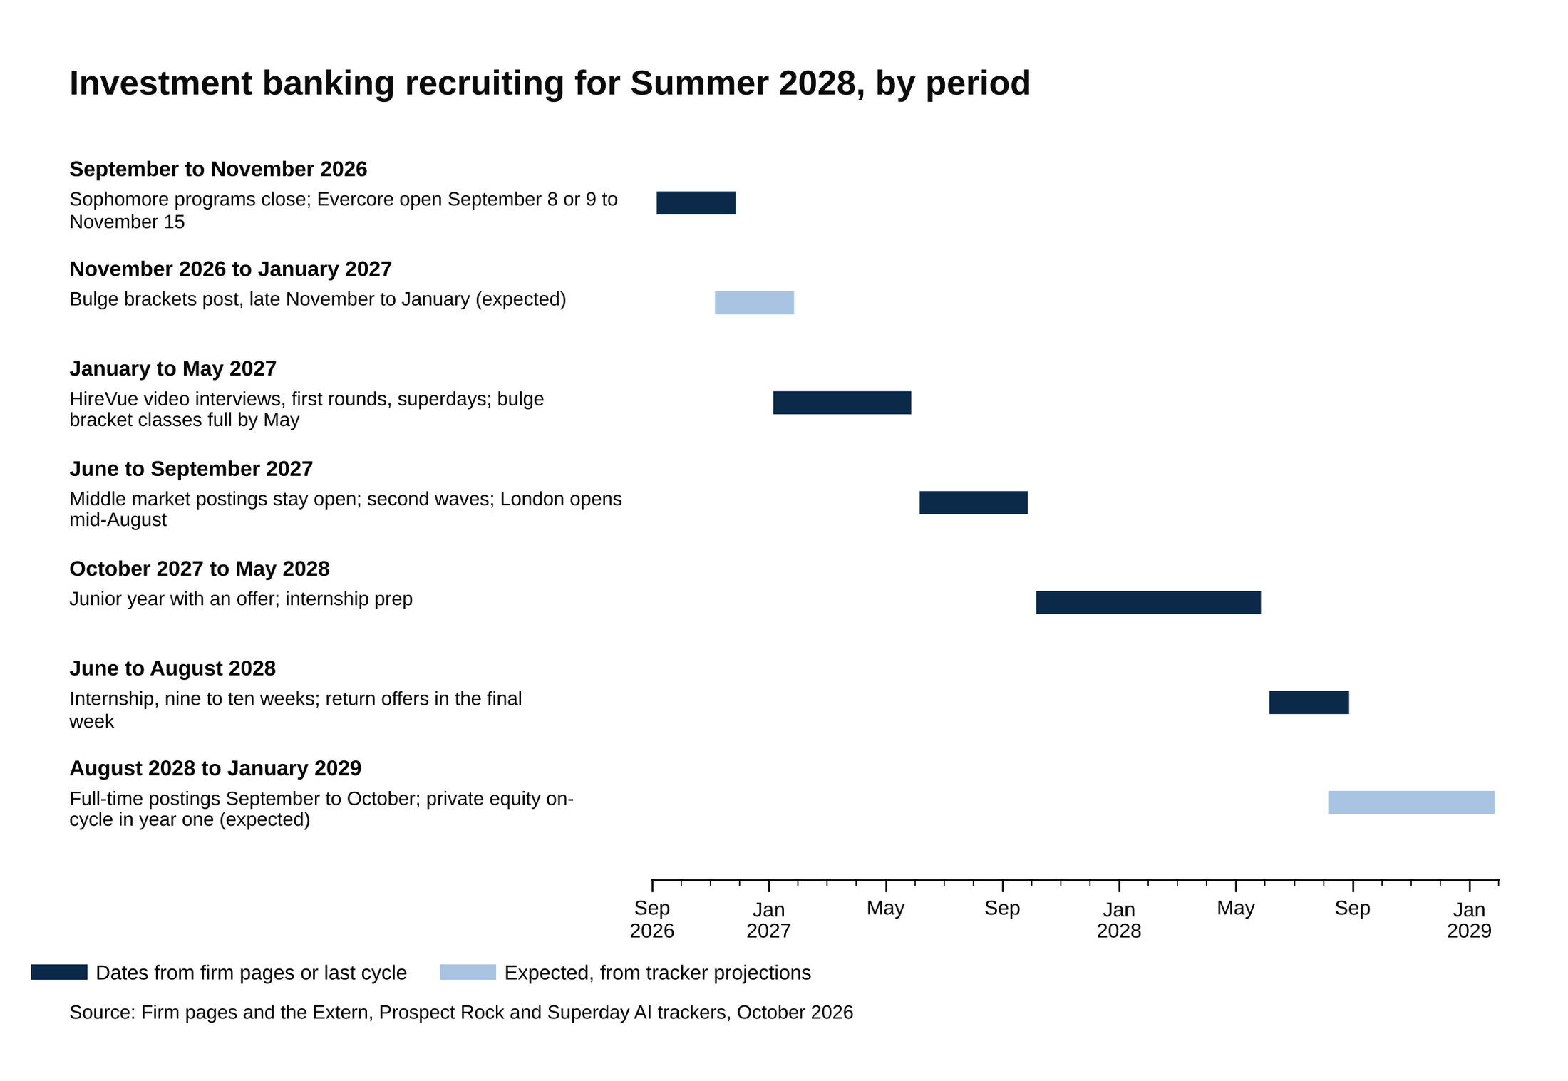
The cycle runs about 22 months, and the bulge bracket seats are decided between December 2026 and May 2027.
Source: Firm pages and the Extern, Prospect Rock and Superday AI trackers, October 2026.

Fall 2026: sophomore and insight programs are the first deadlines
Sophomore and insight programs are the events a bank runs for sophomores in the fall and winter. Houlihan Lokey's is one Insight Day in New York or Chicago. Citi's is three weeks, virtual. Morgan Stanley's is two evening sessions in November. The JPMorganChase Fellowship is a five-week paid summer. What they share is what happens afterward: the bank has your resume, you've met the recruiters, and several firms say outright that participants interview early for the summer seat.

Seven sophomore programs close between October 18 and October 30, 2026, so the first real deadlines of this cycle fall in the next three weeks. [VERIFY: each deadline against the program page at publish]

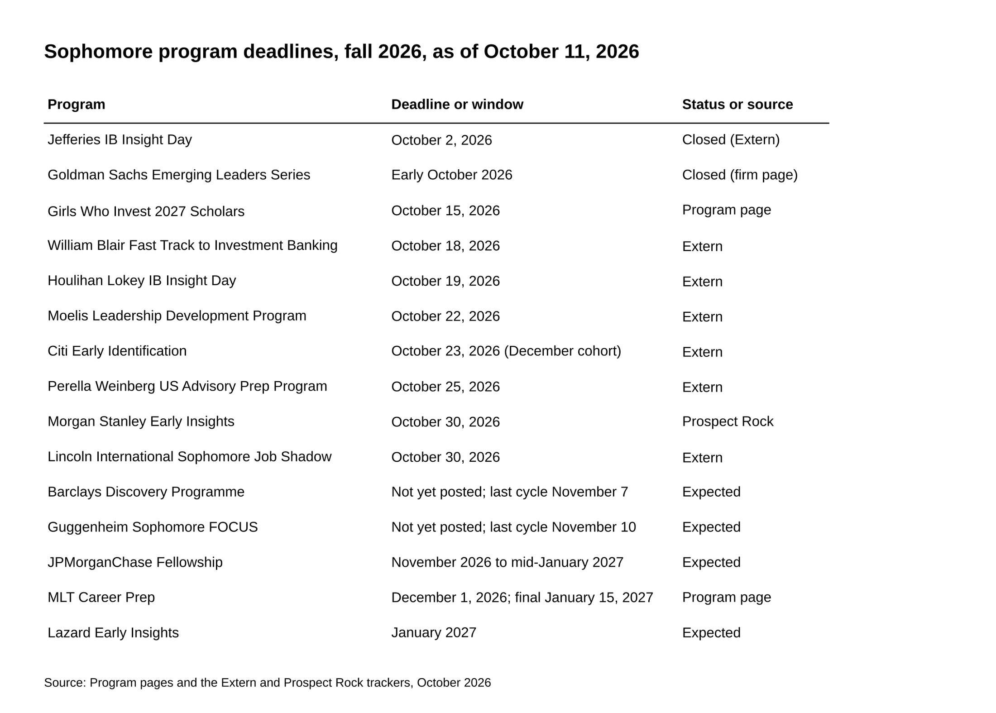
Seven programs close between October 18 and October 30, 2026, and four more are expected in November and January.
Source: Program pages and the Extern and Prospect Rock trackers, October 2026.

Here's every program with a date, as of October 11, 2026.

Program | Who it's for | Deadline or window | Status
Jefferies IB Insight Day | Sophomores (Class of 2029) | October 2, 2026 | Closed (reported by Extern) [VERIFY: at publish]
Goldman Sachs Emerging Leaders Series | Sophomores graduating December 2028 to June 2029 | Closed in early October 2026; the page no longer shows the deadline | Closed (firm page says "Applications are now closed") [VERIFY: the exact deadline, reported as October 4]
Girls Who Invest 2027 Scholars | Students graduating fall 2028 to spring 2030 | Final deadline October 15, 2026 | Program page via a university career hub [VERIFY: at publish]
William Blair Fast Track to Investment Banking | Sophomores | October 18, 2026; Chicago event November 19 to 20 | Reported by Extern [VERIFY: at publish]
Houlihan Lokey IB Insight Day | Sophomores | October 19, 2026; New York November 10 or Chicago December 3 | Reported by Extern [VERIFY: at publish]
Moelis Leadership Development Program | Sophomores; participants interview for the US Summer Analyst seat | October 22, 2026 | Reported by Extern; Prospect Rock says last cycle closed October 31 [VERIFY: at publish]
Citi Early Identification | US sophomores; three weeks, virtual | October 23, 2026 for the December cohort, per Extern; Citi's own page says the December cohort opens in November and the March cohort in February | Reported by Extern; Citi's page gives months, not dates, and its November line conflicts with the October 23 close [VERIFY: at publish]
Perella Weinberg US Advisory Prep Program | Sophomores; participants are invited to interview for the Summer 2028 program | October 25, 2026 | Reported by Extern [VERIFY: at publish]
Morgan Stanley Early Insights | Sophomores graduating December 2028 to June 2029 | October 30, 2026; sessions November 2 and 5 | Sessions on the firm's posting; deadline reported by Prospect Rock [VERIFY: at publish]
Lincoln International Sophomore Job Shadow | Sophomores; one day in Chicago on November 20 | October 30, 2026 | Reported by Extern [VERIFY: at publish]
Barclays Discovery Programme | Students two years from graduation | Not yet posted in the US; last cycle posted October 14 with a November 7 deadline | Expected (Extern, Prospect Rock) [VERIFY: at publish]
Guggenheim Sophomore FOCUS | Sophomores | Not yet posted; last cycle's deadline was November 10 | Expected (Extern) [VERIFY: at publish]
JPMorganChase Fellowship | Sophomores; five-week paid summer | Expected to open in November 2026 and close in mid-January 2027; last cycle ran November 11, 2025 to January 13, 2026 | Firm page says apply when open; dates expected per Prospect Rock [VERIFY: at publish]
UBS Tomorrow's Talent IB Insights Day | Sophomores | Late-fall deadline, January event in New York | Expected (Prospect Rock) [VERIFY: at publish]
MLT Career Prep | Sophomores graduating fall 2028 to summer 2029 | General deadline December 1, 2026; final January 15, 2027 | Program page [VERIFY: at publish]
Lazard Early Insights | Sophomores | Expected January 2027; typically January 15 to February 15 | Expected (Extern) [VERIFY: at publish]
Goldman Sachs Possibilities Series | First-years | Opened February 1, 2026 last cycle | Reported by Prospect Rock [VERIFY: at publish]
SEO Career | First-years to juniors, 3.2 GPA (3.0 considered), US work authorization | Rolling; the Success Class "typically closes in mid-April" | Program page [VERIFY: at publish]
Bank of America sophomore program | Sophomores | No Summer 2027 sophomore posting live as of October 8, 2026; Prospect Rock says fall 2026, dates to be announced | Expected [VERIFY: at publish]

Apply on each program's own page: the JPMorganChase Fellowship, Citi's pre-internship programs, Morgan Stanley's students and graduates page, MLT Career Prep, SEO Career and Girls Who Invest, plus Goldman's Emerging Leaders Series page when it reopens. For the boutique programs, Extern's 2028 internships guide keeps the live links in one place and was updated October 9.

Here's what each one feeds into. Perella Weinberg's Prep Program page says selected participants are invited to interview for the Summer 2028 analyst program. The Moelis Leadership Development Program interviews its participants for the US Summer Analyst seat. In Prospect Rock's summary of the program pages, Houlihan Lokey's Women's Insight Day and RBC's Insights program both offer "the chance for an accelerated interview." Prospect Rock's Class of 2029 guide says participants "routinely receive accelerated interviews and priority consideration," but no firm publishes how many of its Summer Analyst seats come through these programs. WSG's own estimate, in our sophomore insights programs post, is that students who get into one of these programs are roughly 5 to 10 times more likely to convert into a Summer Analyst offer than students who skip them and apply through the open portal.

Missing one doesn't close a door.

If Goldman's Emerging Leaders deadline went by, the open Summer 2028 application still arrives in January. [VERIFY: Goldman's January posting] Apply to what's still open this month and move on to the boutiques.

September to November 2026: elite boutiques open first
Evercore is the firm that moved. Its Summer 2028 postings went up in the second week of September 2026 (Extern has September 9, Superday AI September 8) for New York generalist, Chicago, Houston, Menlo Park, San Francisco, Richmond and Toronto, plus Restructuring and Equity Capital Markets, and every one of them closes November 15, 2026. [VERIFY: Evercore's job board at publish] Superday AI's tracker puts that about four months earlier than Evercore's prior two cycles. Extern reports that Evercore's posting says applications are "not reviewed on a rolling basis," which would make this one window the exception to the day-one rule. [VERIFY: Evercore's review timing, reported by Extern] Submit before November 15 either way. Evercore's students page links to the job board.

Last cycle shows what the interviews look like. Superday AI and Extern both have Evercore's Summer 2027 application running January 1 to February 1, 2026, with superdays from mid-January. Prospect Rock and Extern's 2027 guide say offers were out by mid-January 2026. Those accounts don't agree on the order, so read it as a range: applications in January, offers between mid-January and early February 2026. A Michigan information session in October 2025 said the application "will open in Winter 2026," which fits the January window. The process itself is consistent across sources: two live first-round interviews of about 30 minutes each, no HireVue, then a superday, with offers within days, per Extern's candidate reports. [VERIFY: Evercore's 2027 dates and interview format]

Harris Williams is the other firm with a window on its own page. The Summer Analyst page lists "Summer 2028," a 10-week program, and an application window of October 2026 to January 2027, with US interviews "during the early spring semester of your sophomore year." Extern projects a late-January posting, so check the firm's page now rather than waiting for a tracker. [VERIFY: Harris Williams posting date]

Perella Weinberg and Moelis have one office each open already:

- Perella Weinberg's Houston energy group, TPH, is open and closes November 10, 2026. Its main US Advisory program is expected in mid-November. Last cycle it was open by December 2025, closed January 18, 2026, and had offers out by mid-January. (Reported by Extern and Vault.) [VERIFY: PWP close dates]
- Moelis Houston posted on October 5, 2026 and closes December 14. The other US offices are expected in late December, which fits the firm's own line that US Summer Analyst applications "typically open in December of your sophomore year." Moelis posts by office, so you apply to a city, and its explore opportunities page describes a Suited Assessment (an online test from an outside vendor) at the application stage, one or two first-round interviews, then an onsite final round. The page also caps you at two applications. (Houston dates reported by Extern.) [VERIFY: Moelis Houston close and the December openings]

The rest of the elite boutiques haven't posted, and the trackers disagree about when they will, so here's each one with its range:

- PJT Partners hadn't posted as of December 2025 (Vault). Superday AI has it opening in early January 2026 and wrapping up by April. Extern expects January 2027. [VERIFY: PJT posting]
- Centerview keeps a resume drop open all year, so you can submit at any time. Prospect Rock calls it "permanently rolling" and says to apply in the fall; Extern's Centerview guide expects a formal window of January to March 2027. Extern's 2027 guide says offers were out by mid-January 2026, so read it as "fall resume drop, interviews mid-January to March, depending on the tracker." [VERIFY: Centerview window]
- Lazard was open as of December 22, 2025 per Vault, while Extern's Lazard guide places general applications in March to April 2026, so read it as "December to April, depending on the tracker." Lazard runs a HireVue, then a phone screen, with superday invitations by June. Extern expects December 2026. [VERIFY: Lazard posting]
- Houlihan Lokey opened in fall 2025 per Superday AI, or after the bulge brackets into spring and summer per Prospect Rock. That's the widest conflict on the list, so watch the firm's careers page from November. [VERIFY: Houlihan Lokey posting]
- Guggenheim posted in January 2026. Extern expects January 2027. [VERIFY: Guggenheim posting]

Last cycle, Evercore, PJT, Moelis, Lazard, Perella Weinberg, Centerview and RBC had Summer 2027 offers out by mid-January 2026, the same month most bulge brackets were still posting. That's Prospect Rock's account; Extern's 2027 guide names Evercore, Perella Weinberg, Centerview and RBC. A student who waits for the Goldman posting to start preparing has already missed the Evercore close and most of the boutique superdays.

December 2026 to January 2027: bulge brackets open and the clock starts the day they post
No bulge bracket has posted a Summer 2028 Investment Banking Summer Analyst role as of October 11, 2026. [VERIFY: posting status at publish] The best evidence for when they will is when they posted last time, so here is the Summer 2027 cycle firm by firm, with Extern's projection for this one.

Firm | Summer 2027 application opened | Closed | Expected for Summer 2028 (Extern)
Goldman Sachs | IB posting live by January 1, 2026 (reported; posters applied that day) | By spring 2026 | January 2027
JPMorgan | December 2025 to March 2026, depending on the tracker (Prospect Rock says December; Extern says January to February; Superday AI says around March) | By July 2026 | December 2026
Morgan Stanley | January 1, 2026 | February 15, 2026 | January 2027
Bank of America | December 2025 to January 2026; the firm calls it rolling and says "programs will close as positions are filled" | As filled | January 2027
Citi | December 2025 to January 2026 | January 2026 | December 2026
Barclays | December 2025 to January 2026 | January 2026 | Late November 2026
UBS | December 2025 to January 2026 | January 2026 | January 2027
Deutsche Bank | December 2025 to January 2026, plus a fall wave in August and September 2026 | January 2026; fall wave in September | Late November 2026
Wells Fargo | December 2025 to January 2026 | January 2026 | January 2027
RBC | Open by December 12, 2025 | January 30, 2026 | Not projected
Jefferies | Late 2025 to early 2026 | Closed by fall 2026 | December 2026

The Summer 2027 columns come from Prospect Rock's Class of 2029 guide, Extern's 2028 guide, Superday AI, Vault and eFinancialCareers, with the Goldman and Deutsche Bank details from Wall Street Oasis threads. [VERIFY: Extern's projections against the actual postings]

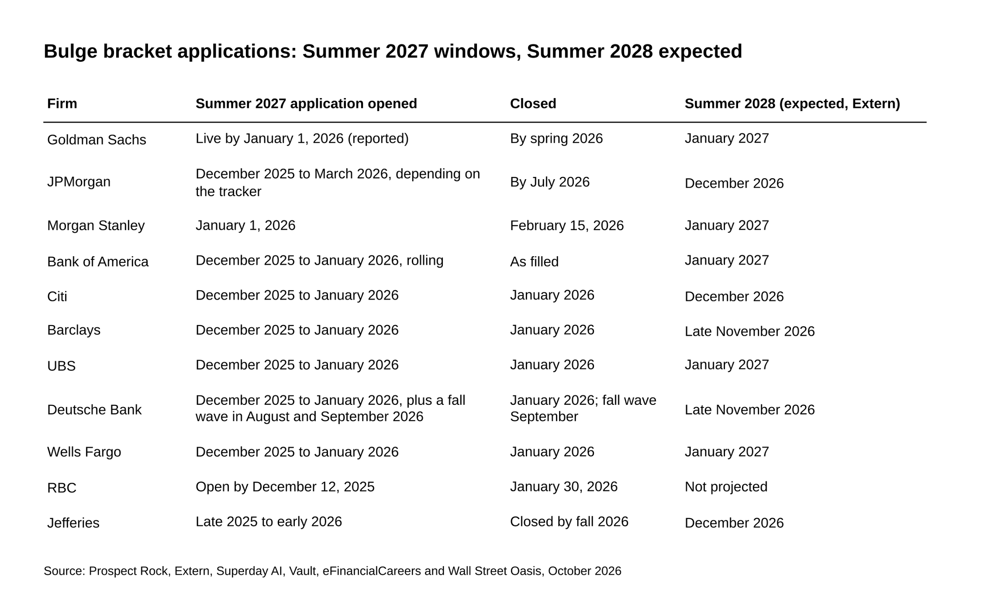
Ten of the eleven banks opened in December 2025 or January 2026, and Extern expects the same months again.
Source: Prospect Rock, Extern, Superday AI, Vault, eFinancialCareers and Wall Street Oasis, October 2026.

Morgan Stanley ran its Summer 2027 application from January 1 to February 15, 2026, so expect the same window in 2027 and treat January 1 as the day to submit. [VERIFY: Morgan Stanley's 2028 window when it posts]

The reason is that the applications are rolling. A rolling application means the bank reads applications in the order they arrive and sends HireVue invitations as it reads, so interviews start while the posting is still open and seats get filled before it closes. Bank of America says it plainly on its own posting: "programs will close as positions are filled." Goldman shows the speed. Its IB posting was live by January 1, 2026, and posters on Wall Street Oasis who applied that day reported HireVue invitations within hours to about two days, arriving in waves. Offers went out in March and April. Someone who applied on February 1 entered the same funnel a month behind every wave, with fewer seats left in it. Morgan Stanley works differently: its HireVue is due about two days after the February 15 deadline, so every video lands at once and superdays roll through the spring. Even there, the application itself is due on a fixed date, and nothing is gained by waiting.

Day one is the deadline.

The volume numbers say the same thing. Adventis tracks a little under 200 firms and counts each one in the month of its first posting. For Summer 2027, 28 firms first posted in December 2025 and 47 in January 2026, and it counted 350 separate postings in January alone. Its Summer 2028 forecast is 2 firms in September 2026, 2 in October, 11 in November, 27 in December and 46 in January 2027, with new postings peaking at 349 in January 2027. [VERIFY: Adventis's forecast at publish] January 2027 is the month with the most postings, so it's the month to have the resume, the story and the technicals ready.

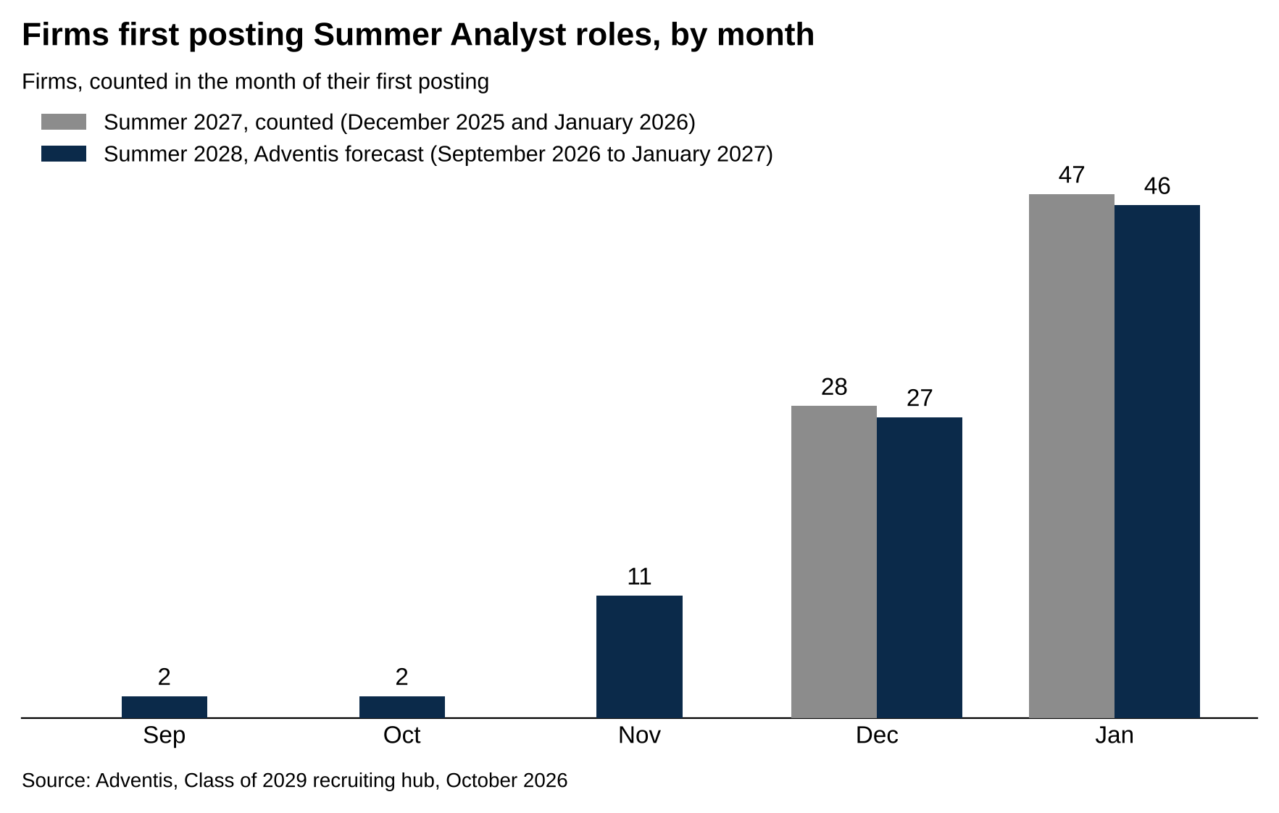
Adventis forecasts 46 firms first posting in January 2027, against 47 in January 2026.
Source: Adventis, Class of 2029 recruiting hub, October 2026.

For what each bulge bracket program looks like once you're inside the portal, our 10 investment banking internships to apply to in 2027 post goes firm by firm.

January to April 2027: HireVue in days, first rounds in weeks, superdays by spring
HireVue is a recorded, one-way video interview. A question appears on screen, you get about 30 seconds to think, and the camera records your answer for 90 seconds to two minutes. Nobody is on the other end live; recruiters watch the recording later. At JPMorgan it's three to five mostly behavioral questions with one retry per question, per Extern's JPMorgan guide (citing IGotAnOffer). At Goldman, posters on Wall Street Oasis report one take per question, and Extern says sources conflict on retries, so plan for one take. [VERIFY: question counts and retry rules]

Here are the gaps between steps, by bank:

- Goldman sends the HireVue invitation after a resume screen, and Extern says the invitation expires "about a week after receipt." Posters in January 2026 reported invitations within hours to about two days of applying, arriving in waves. [VERIFY: Goldman's HireVue lag and expiry]
- JPMorgan publishes no lag between application and HireVue. Our JPMorgan superday post notes that a superday invitation there means you've already cleared the HireVue and a first-round interview.
- Morgan Stanley's HireVue is due about two days after the application deadline, so with a February 15 close, expect the video due around February 17. [VERIFY: Morgan Stanley's HireVue timing]
- Across the banks, Prospect Rock describes video and test deadlines as "3-to-7-day" completion windows. Treat a HireVue invitation as something you finish inside a week, not something you schedule.
- Evercore and Moelis skip HireVue. Evercore runs two live interviews of about 30 minutes each, and Moelis runs a Suited Assessment at the application stage, then one or two first rounds.

A superday is the final round, a block of back-to-back interviews in one day. Goldman's is three to five interviews of about 30 minutes each, with decisions usually within two to seven days, per our Goldman Sachs superday post. JPMorgan's is four to six interviews of 30 to 45 minutes, four to six hours in total, and the conversion from superday to offer there runs about 30 to 40 percent in a typical cycle, per the JPMorgan post above. The whole Goldman sequence, from application through superday, is in our round-by-round breakdown.

Put the pieces together for one Goldman application on January 1, 2027, using last cycle's gaps. January 1: submit. January 1 to 3: HireVue invitation, since posters reported hours to two days. By about January 10: HireVue done, because the invitation expires in about a week. Late January to March: superday. March to April: offer, which is where Extern's 2027 guide places Goldman's Summer 2027 offers. [VERIFY: each gap against this cycle] At the accelerated boutiques the same chain ran from fall into mid-January. At the bulge brackets it ran into May.

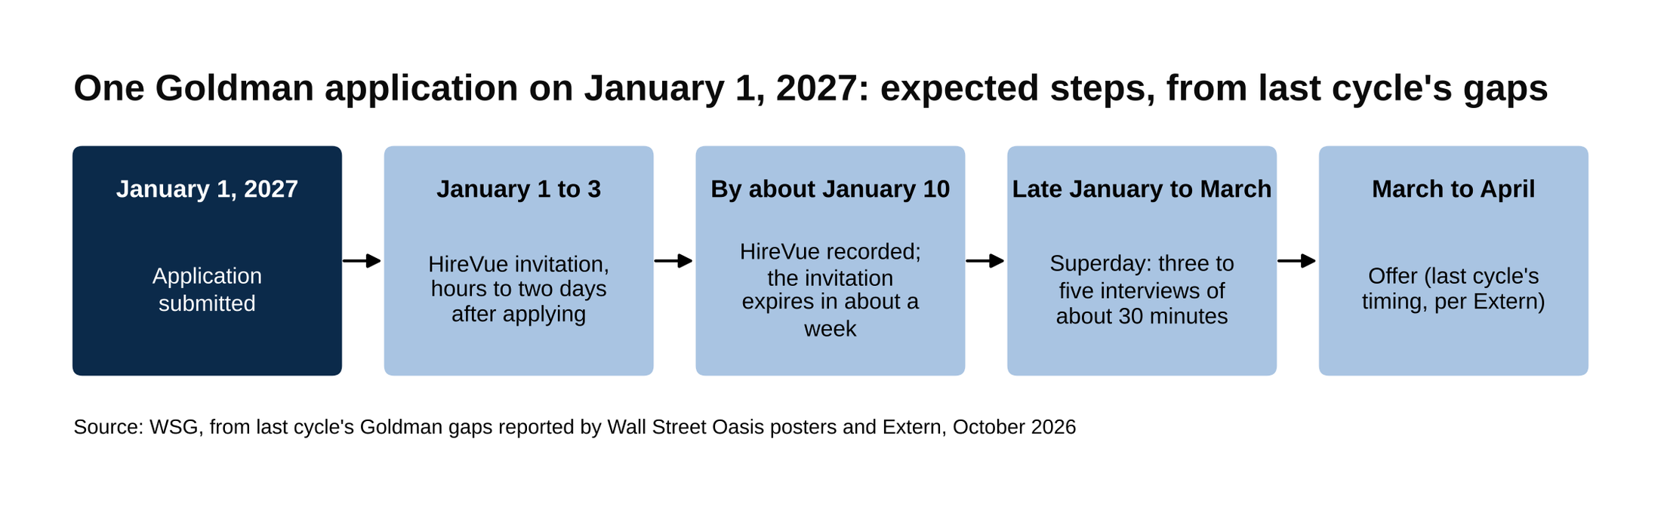
A Goldman application on January 1 reaches the HireVue within days and an offer by March or April.
Source: WSG, from last cycle's Goldman gaps reported by Wall Street Oasis posters and Extern, October 2026.

Bulge brackets had their Summer 2027 classes essentially full by May 2026, about five months after most of them posted. [VERIFY: Prospect Rock's "essentially full by May 2026" claim; confirm the pattern in May 2027] Extern's Summer 2027 guide counted 106 firms with 729 Summer 2027 finance positions posted by May 2026, and Adventis had 114 firms posted by September, so a good share of the postings came after the bulge bracket classes were full. That's the middle market and second-wave story in the next section. For the bulge brackets, though, the window from first posting to full class was December to May.

The prep has to be done before January 1, not after. The HireVue arrives in days and the superday follows in weeks, and there is no point in the sequence where a bank pauses so you can learn accounting. Start with our 2026 interview guide for sophomores and work through it between now and December.

Spring to fall 2027: the middle market and the second waves
Middle market banks post later and keep posting longer.

Baird says on its own careers page that its application opens in late December for two weeks, with superdays in late February and invitations one to two weeks before. [VERIFY: Baird's dates on its page at publish] Two weeks from late December puts the close in early to mid-January, and the same page lists phone or campus first rounds in January and February. One wrinkle for this cycle: Extern reports that Baird posted Chicago and Milwaukee roles on October 8, 2026, two months ahead of the firm's stated late-December open, so check the page now rather than in December. [VERIFY: whether Baird's October posting is the Summer 2028 Summer Analyst role] Piper Sandler's hiring timelines page runs the whole thing in two months: applications open in January, close in February, first rounds in February, internship June to August. [VERIFY: Piper Sandler's dates at publish]

The others are rolling. William Blair posts after the bulge brackets and still had multiple Summer 2027 group postings live in September 2026. Raymond James posts after the bulge brackets too, with roles still up in October 2026. Lincoln International had a valuations role posted in October 2026. Harris Williams, covered above, closes in January. [VERIFY: each firm's postings at publish] Adventis counted 114 of the just under 200 firms it tracks as having posted Summer 2027 roles by September 1, 2026, which leaves roughly 80 that hadn't, nine months before the internship. That count is the clearest evidence that the cycle doesn't end in May.

Then there are the second waves at the biggest banks, for seats still open after the spring:

- Deutsche Bank ran a fall Summer 2027 wave in August and September 2026. A Wall Street Oasis thread on it started August 3, 2026; posters cite a close of September 9 or "the 14th," so read it as "September 9 to 14, reported," with New York first rounds in September. [VERIFY: whether Deutsche Bank runs a fall 2027 wave]
- Goldman posted a new firm-wide Summer 2027 application across several divisions, investment banking included, on August 15, 2026. Posters on Wall Street Oasis read it as a second wave for remaining seats but couldn't confirm how many were investment banking seats. [VERIFY: whether Goldman repeats the August 15 opening in 2027, and what it covered]
- Jefferies, closed since early 2026, posts occasional group-level roles.

For a sophomore on this cycle, those waves translate to August and September 2027: a second shot at Deutsche Bank and Goldman if the first wave didn't land, running alongside the middle market postings that are still open.

London runs on its own calendar. The UK Summer 2027 windows opened in mid-August to early September 2026 (Goldman August 15, JPMorgan August 31, Morgan Stanley September 7 to November 15, per the Intervyo tracker, which carries no update stamp), Harris Williams's page says its London applications open in late August or early September for three to four weeks, and Moelis says its London applications "typically open in August." If you're applying to London for Summer 2028, expect the windows in August 2027, three months after the US bulge bracket classes are essentially full. [VERIFY: London 2028 windows when posted]

Summer 2028: the internship and the return offer
The Summer 2028 internship is nine to ten weeks, June to August. Goldman's runs 9 to 10 weeks, JPMorgan's investment banking program 9, Morgan Stanley's about 10, Evercore's and Harris Williams's 10, and Piper Sandler's from June to August, per the firms' pages and Extern's guides. [VERIFY: program lengths on each firm's 2028 posting]

Return offers usually go out in the final week of the internship or shortly after, and no bank publishes what share of its interns gets one. [VERIFY: return offer timing] Some banks push the decision to early fall, per IB Interview Questions' recruiting timeline guide. The same guide puts return offer rates at "70-90%" without naming a source, and forums quote the same range; treat it as a crowd-sourced figure. [VERIFY: return offer rate, unverified]

An intern who converts has a full-time Investment Banking Analyst seat starting in summer 2029 and a senior year without a recruiting cycle. An intern who doesn't convert, or who turns the offer down, enters the full-time cycle in the next section. The mechanics of converting are in our summer internship conversion post.

August 2028 to January 2029: the full-time investment banking recruiting timeline and PE on-cycle
Full-time recruiting without a return offer runs on a senior-year calendar. Postings open in September and October of senior year, and interviews run from October into the winter, with offers from fall into early spring depending on the source (IB Interview Questions' recruiting timeline guide says offers go out through the fall; Leland's says late winter or early spring). Wall Street Oasis's full-time 2027 application thread was active in October 2026, which is the same pattern a year ahead of you. [VERIFY: full-time posting months in fall 2028] These postings are for the seats interns didn't fill, so there are fewer of them than summer seats. If you're in that position in August 2028, the move is to apply in the first week postings appear, for the same rolling reason as the summer cycle.

Private equity on-cycle recruiting is the other calendar that starts the moment you have a full-time offer. "On-cycle" is the compressed window, usually a few days, in which the large private equity firms and their headhunters interview first-year bank analysts for associate jobs that start about two years later. In 2025 the banks pushed back on how early it ran: on June 4, 2025, JPMorgan's co-heads of global banking, Filippo Gori and John Simmons, sent incoming US analysts a memo, reported by Fortune, saying that if you accept a position with another company before joining or within your first 18 months, "you will be provided notice and your employment with the firm will end." Apollo (June 11) and General Atlantic (June 12) then said they would not interview or extend offers that year for the class of 2027, per Banking Dive, and on July 9, 2025, eFinancialCareers, citing Bloomberg, reported that Goldman's investment banking juniors would certify every three months that they hadn't accepted jobs elsewhere.

Private equity on-cycle recruiting restarted on Monday, January 5, 2026, after a seven-month pause, and the firms involved interviewed first-year analysts for associate jobs starting 20 months later. [VERIFY: the January 5, 2026 restart (the eFinancialCareers piece of January 7 says "Monday") and the 20-month figure, from the FT via eFinancialCareers] By January 6, Blackstone, Apollo, Carlyle, TPG, Silver Lake, General Atlantic, Hellman & Friedman and Warburg Pincus were interviewing, per the eFinancialCareers account of the Financial Times report; one analyst interviewed at 7:30 in the morning and had accepted a job starting 20 months later by 9 that night.

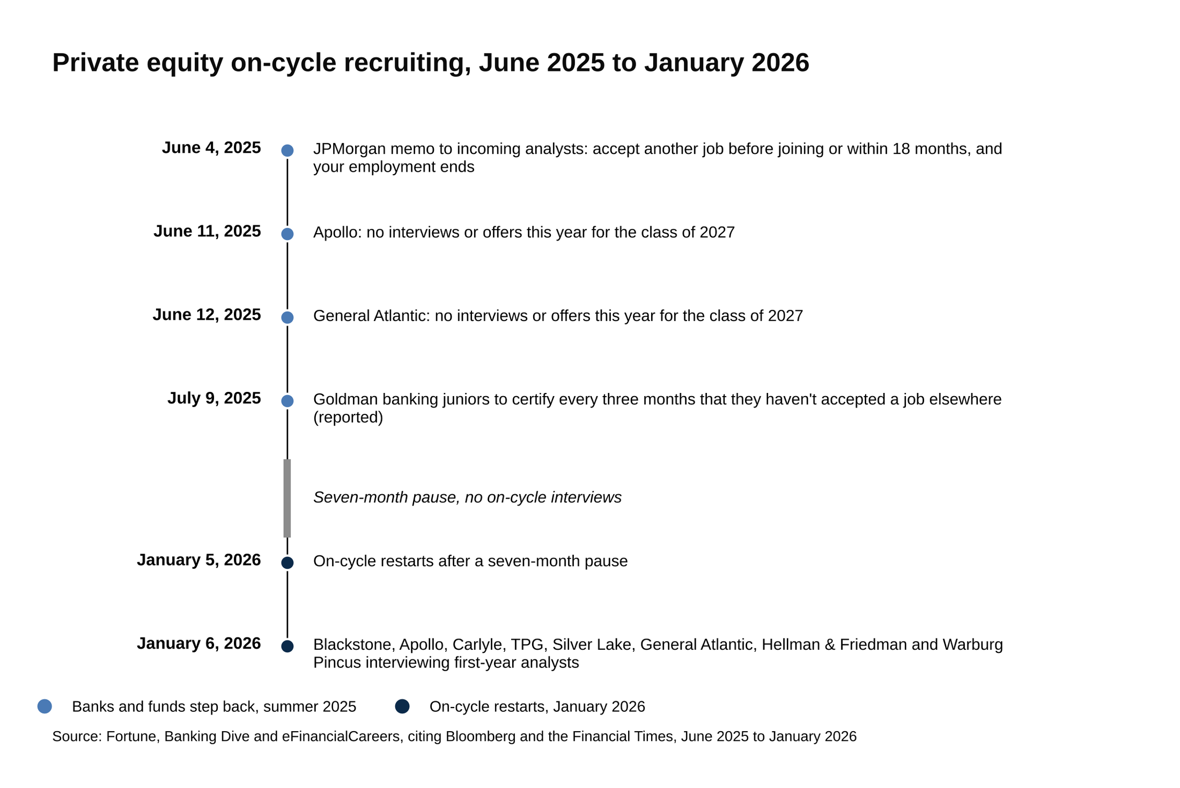
On-cycle recruiting paused after the June 2025 bank memos and restarted on January 5, 2026.
Source: Fortune, Banking Dive and eFinancialCareers, citing Bloomberg and the Financial Times, June 2025 to January 2026.

For a Summer 2028 intern, here's what that calendar means, stated as a projection rather than a date. You'd start full-time in summer 2029. If the January pattern holds, your class's on-cycle would land in early 2030, about six months into the job, for associate seats starting in 2031. If the June pattern comes back, it would hit the summer you start. Either way, two rules from 2025 are now part of the job: at JPMorgan, accepting another position in your first 18 months ends your employment, and at Goldman, you attest every quarter that you haven't. [VERIFY: whether both policies remain in force in 2029] None of that is a reason to decide anything about private equity now. It's a reason to know, before you sign a full-time offer in August 2028, which bank's rules you're agreeing to.

What to do this week
Today is Sunday, October 11, 2026. Here is the order. Every one of these dates can move, so check the page before you plan around it.

- By October 19: Houlihan Lokey IB Insight Day. [VERIFY: deadline at publish]
- By October 22: Moelis Leadership Development Program. [VERIFY: deadline at publish]
- By October 23: Citi Early Identification, December cohort. [VERIFY: deadline at publish]
- By October 25: Perella Weinberg US Advisory Prep Program. [VERIFY: deadline at publish]
- By October 30: Morgan Stanley Early Insights, and Lincoln's Sophomore Job Shadow if Chicago works for you. [VERIFY: deadlines at publish]
- By November 10: Perella Weinberg's TPH Houston group, if energy banking in Houston is a real option for you. [VERIFY: close date at publish]
- By November 15: Evercore's Summer 2028 application, every office you'd take. [VERIFY: Evercore close at publish]
- In November: the JPMorganChase Fellowship when it opens, Barclays Discovery if it posts, and Perella Weinberg's US Advisory program in mid-November. Harris Williams any time its October-to-January window is open. [VERIFY: each opening]
- December 1 and January 15: MLT Career Prep's general and final deadlines, if you're eligible. [VERIFY: MLT deadlines]
- Late December: Moelis's other offices, Baird's two-week window, and the first bulge brackets (Barclays and Deutsche Bank are expected in late November, JPMorgan and Citi in December). Apply the day each posts. [VERIFY: each posting]
- January 1, 2027: Morgan Stanley's window opened on this date last cycle and Goldman's IB posting was already live, so have the resume and the HireVue answers ready before winter break ends. [VERIFY: January postings]

If you do one thing this week, submit Evercore before November 15 and put January 1, 2027 on your calendar as the day the bulge bracket clock starts. [VERIFY: both dates at publish] Everything after that, the HireVue in days, the superday in weeks, the offer by spring, follows from being in the first wave rather than the last.

